14. Write the step by step procedure with snapshot to set stage dimension in flash interface.

Steps for Setting Stage Dimension

* Goto location where you install flash and double click on flash application.
* Create new flash document by clicking on File > New and on the
* General tab, select Flash Document.
* Goto properties by pressing Ctrl+F3 (or click windows menu and choose properties)
* Now, Change the stage dimension like: size, background color and frame rate

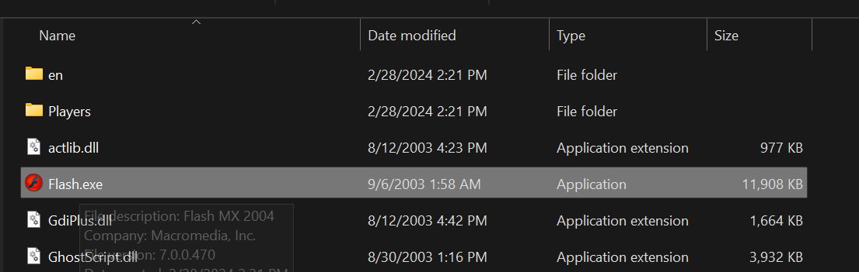

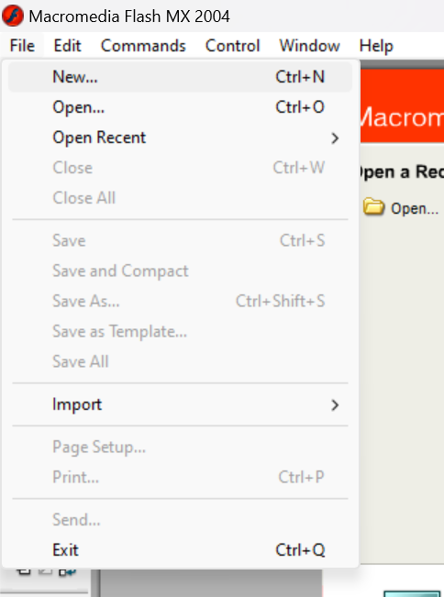

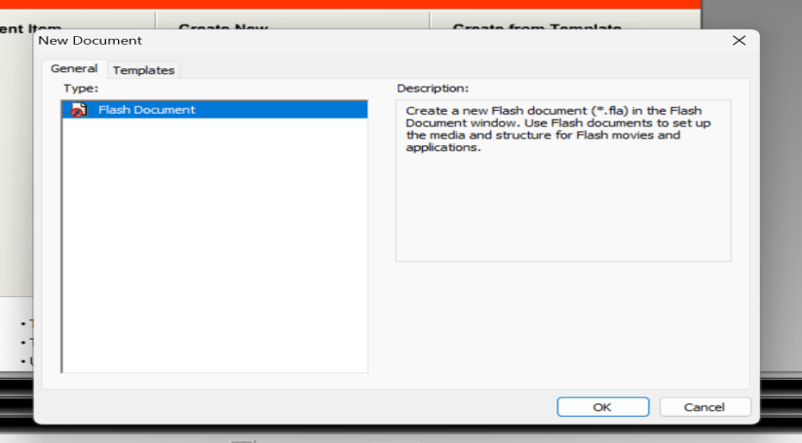

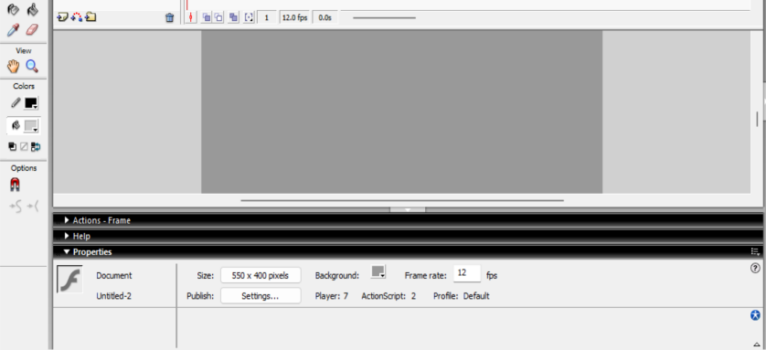

15. Write the step by step procedure with snapshot to modify different shapes in flash interface.

Drawing and Modifying Shapes

* ➢Using Tools panel, draw any shape you would like to make.
* ➢Select the object you draw by using selection tool.
* ➢Click on modify submenu from the menu bar.
* ➢Goto transform option and choose any operation:Scale, rotate, flip etc..) you would like to modify.
* ➢Finally the shape is modified.

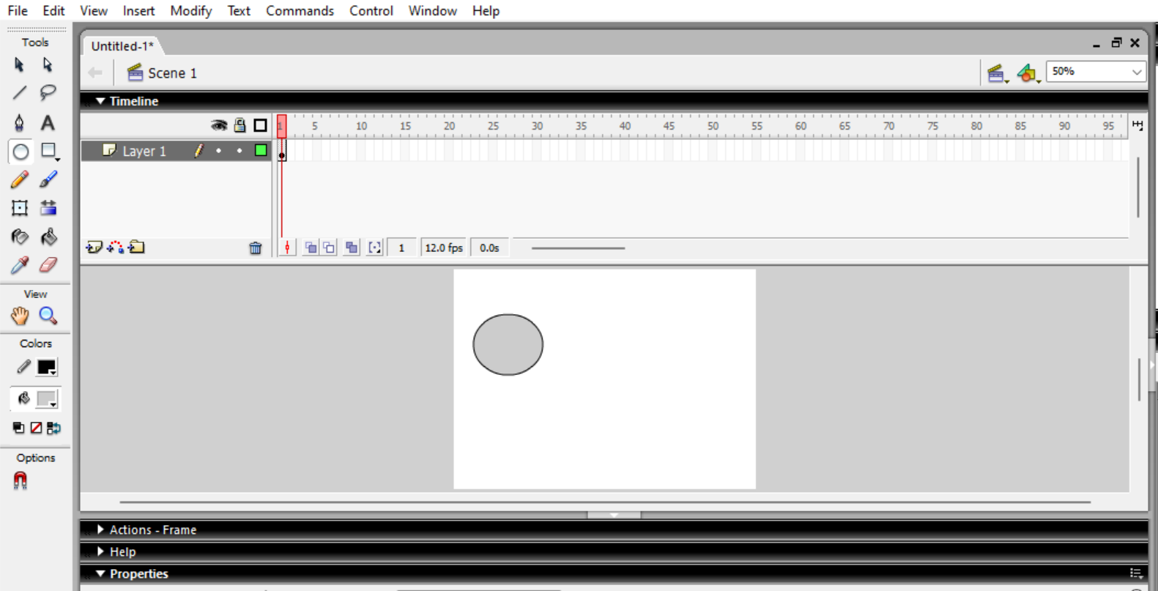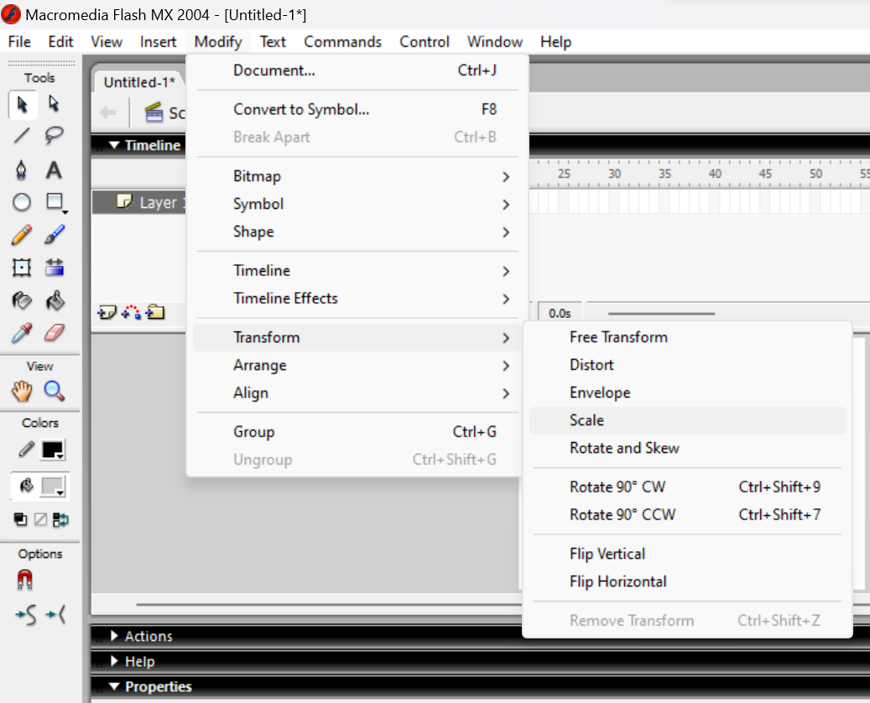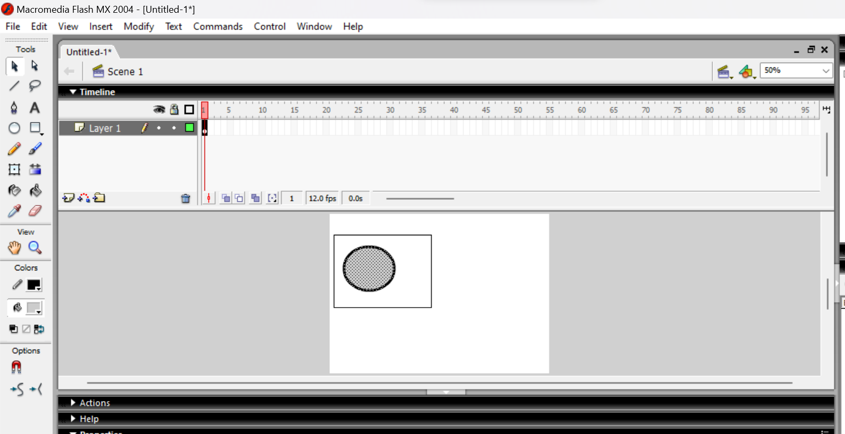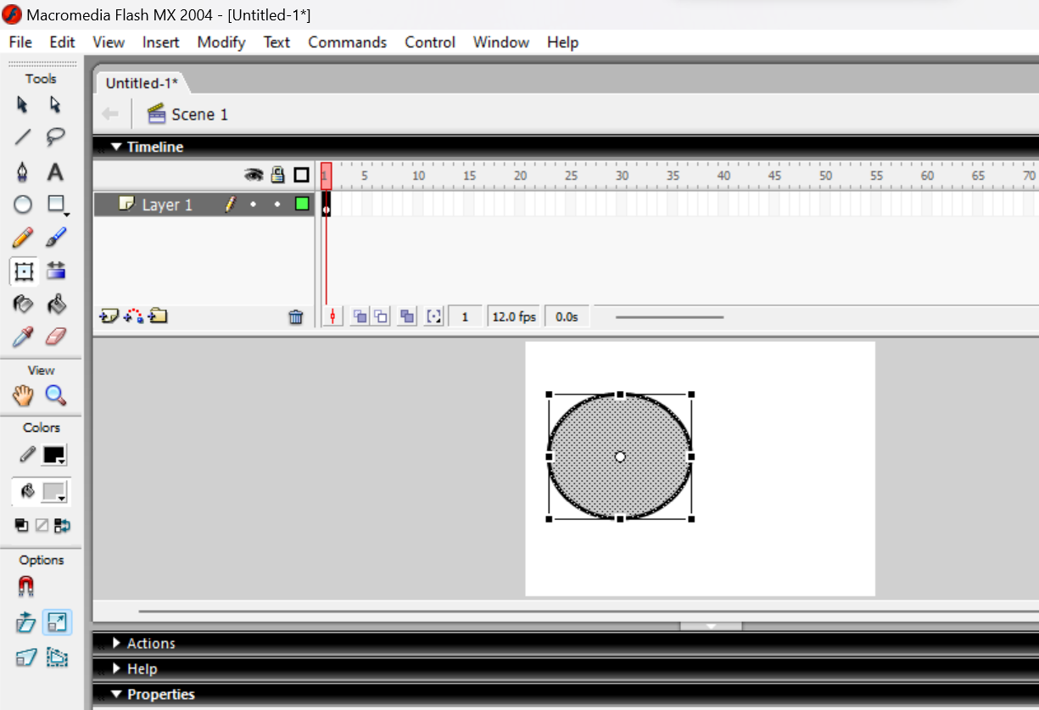

16. Write the step by step procedure with snapshot to work with bitmap images and sounds

on background.

Bitmap Images and Sounds

* Firstly, import image to stage (by clicking File->Import->import to stage and choosing image from drive location) and rename layer1 to image.
* Secondly, import sounds to library (by clicking File->Import-> import to library and choosing sound from drivelocation) .
* Insert a new layer, named sound.
* Drag the frame1 to any frame number(say frame30) and right click on frame 30 and click insert keyframe.
* Goto properties and add sound that you have selected from the desired drive location.
* Click on control submenu and then play option (or Test movie option).

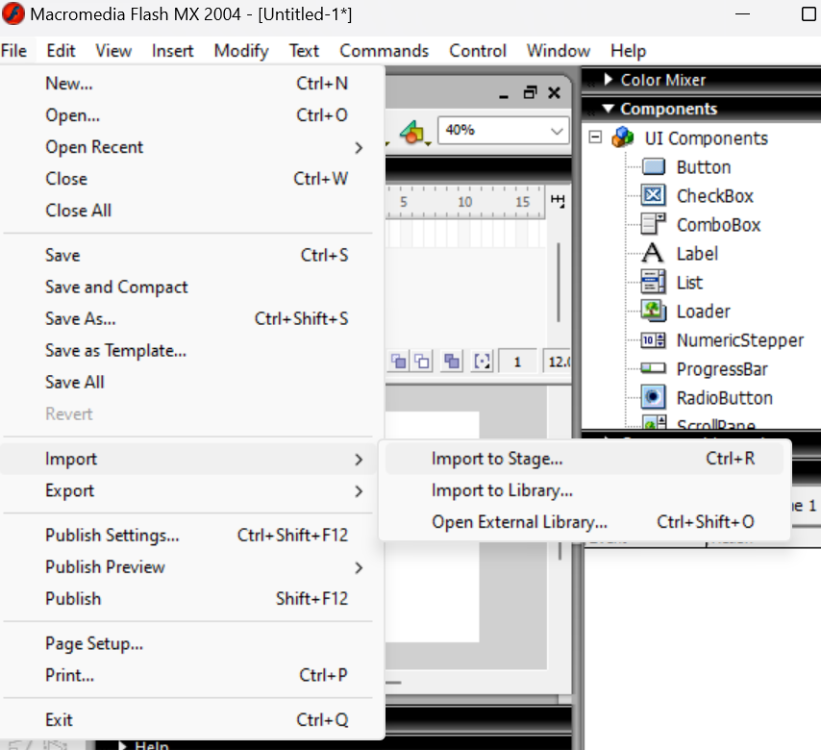

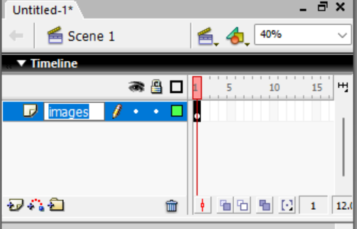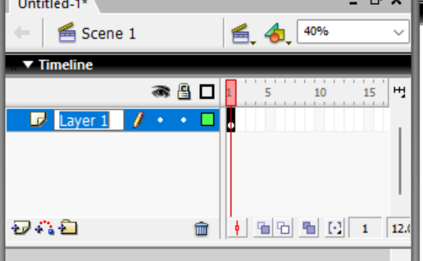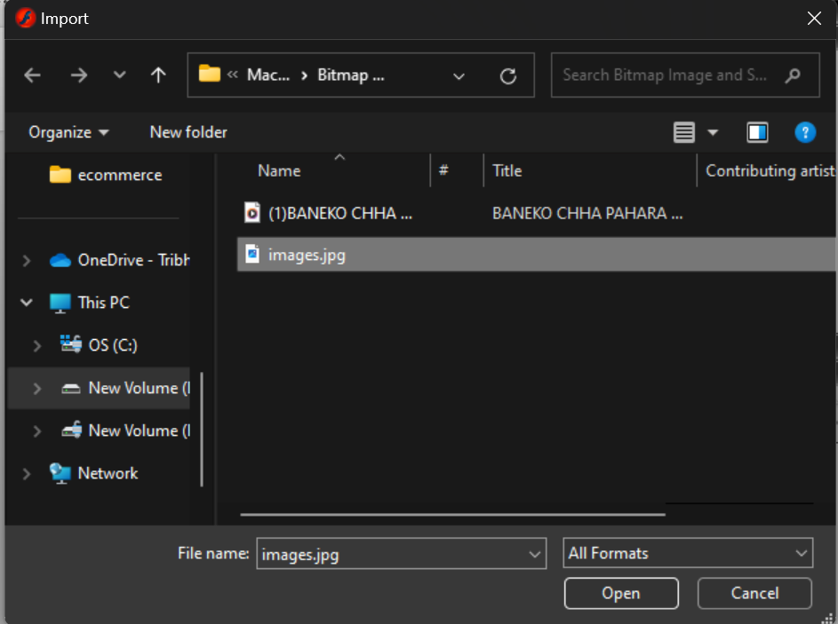

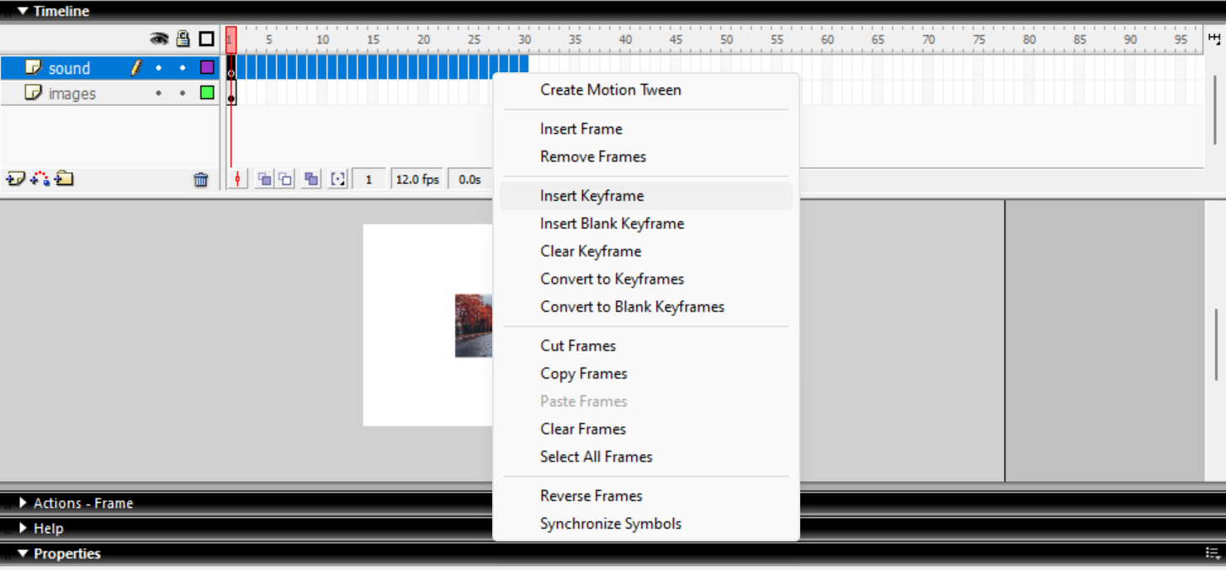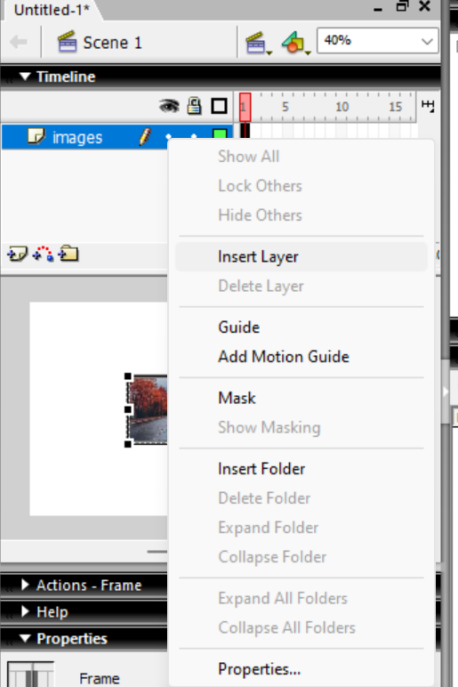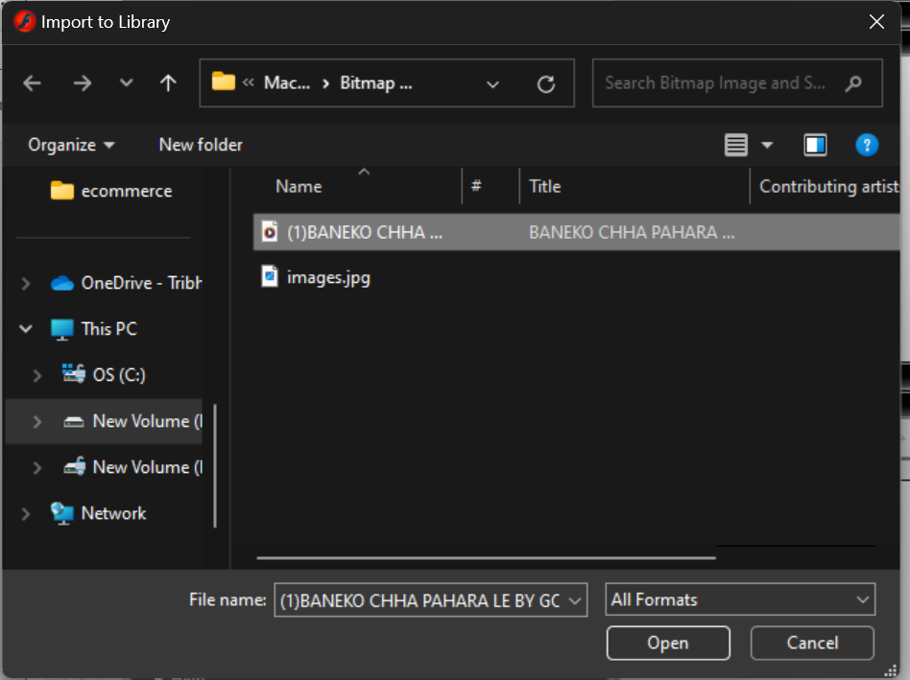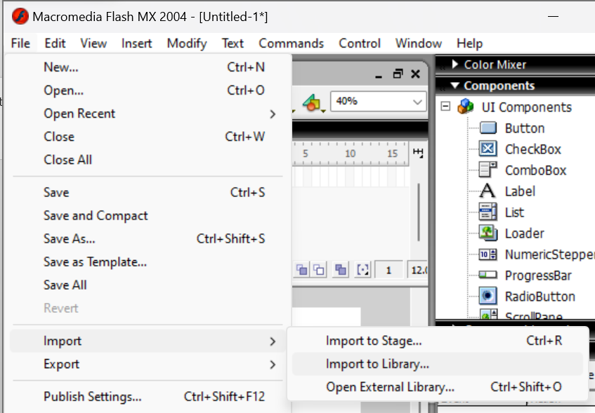

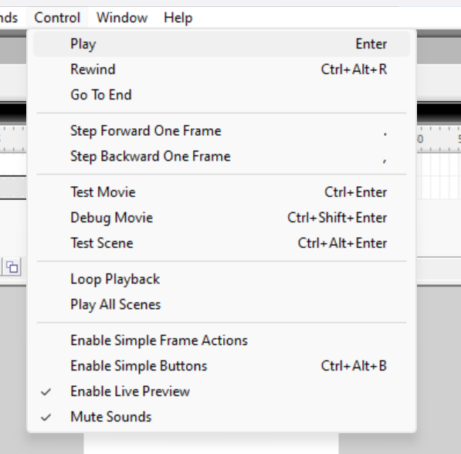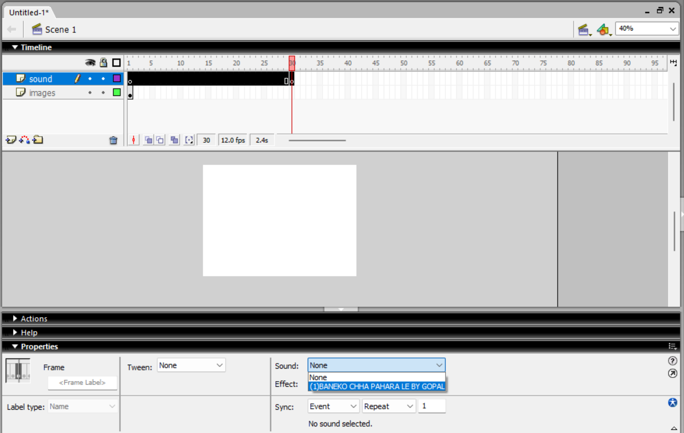c

17. Write the step by step procedure with snapshot to perform frame by frame animation in

flash interface.

* Create a new Flash document
* Open the Modify -> Movie dialog box. For this exercise, select a width and height of 300\*300 pixels. Leave every thing else the way it is.
* In the timeline, select Frame 1 on layer 1 and then draw square box on the stage. Fill it with a color you like using the point Bucket Tool
* Next select frame 2 and insert a new keyframe via the shortcut menu, or by pressing f6.(Notice how the playhead (the red bar on the top row of the timeline) moves to frame 2, indicating that frame 2 is now the active frame)
* Select the box you drew and move it a few pixels to the right.
* Repeat this process for frames 3 through to 5 times
* Now, at the frame 6 insert a new keyframe, and move the square a few pixels down. Repeat this process for frames 7 through 10.(At this point, you’ve created your first animation sequence)
* 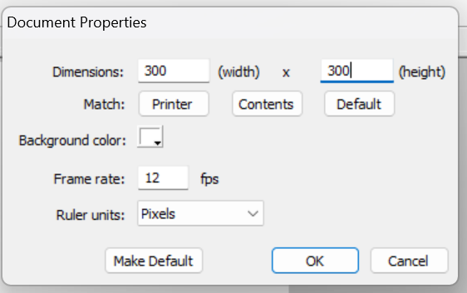Select Control-> Play, or press the Enter key.(flash will play the animation for you by displaying each frame in succession.Note that you can loop the clip via the Control->Loop playback command)

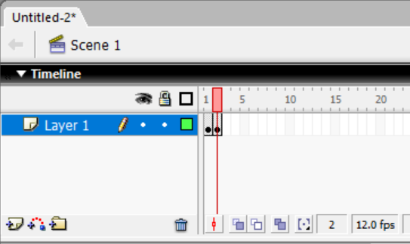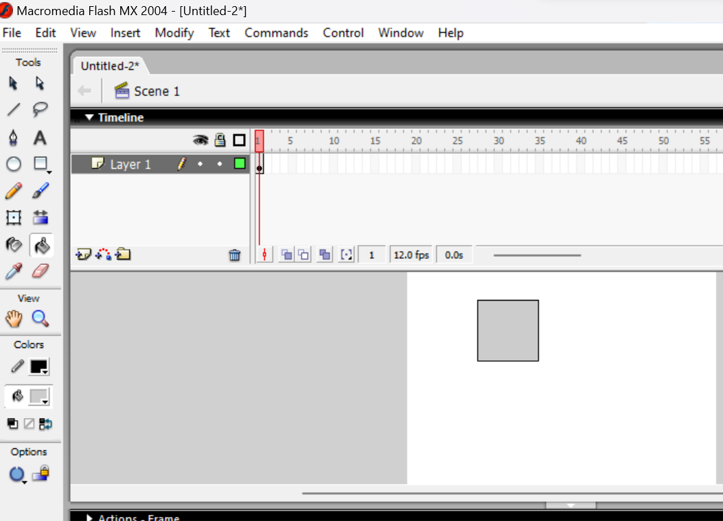

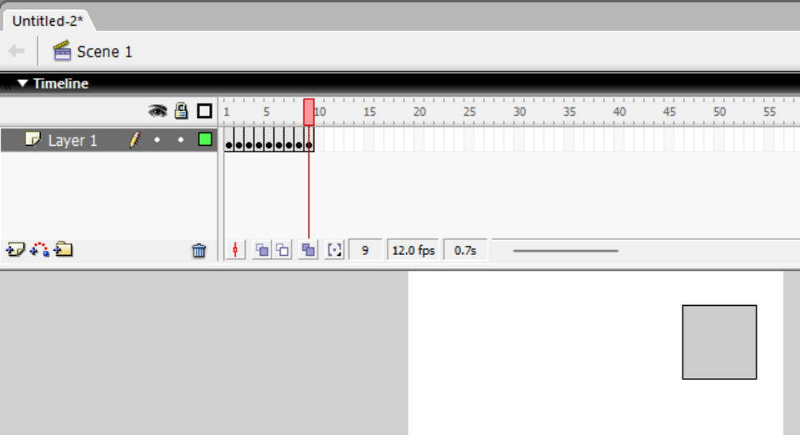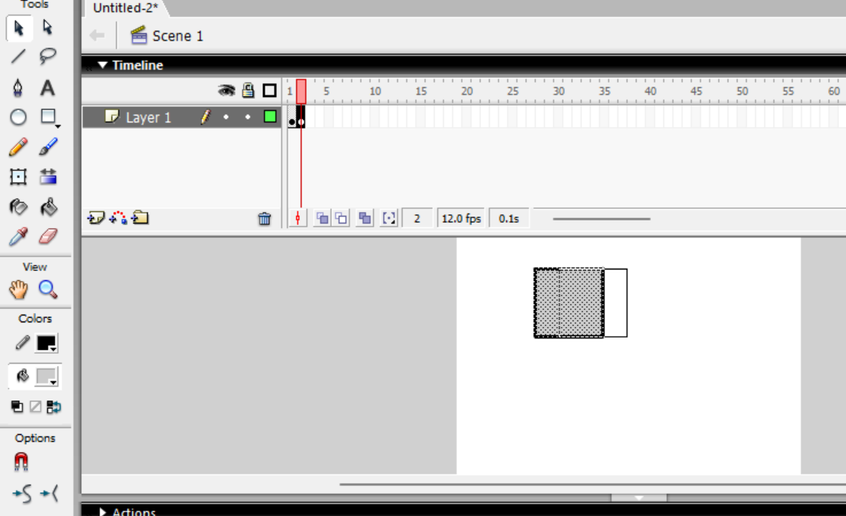

18. Write the step by step procedure with snapshot to perform shape tween in flash interface.

* Open a new flash file
* Select the first frame in Layer 1. Go to the stage and draw circle.
* Select frame 25 and insert a blank keyframe(f7)
* Still keeping playhead on frame 25, draw a polygon on the stage using the polystar too.
* Select any frame between, 2 - 24 and select the shape from the tween drop-down menu in the Property inspector.
* Play you movie to view you motion tween.

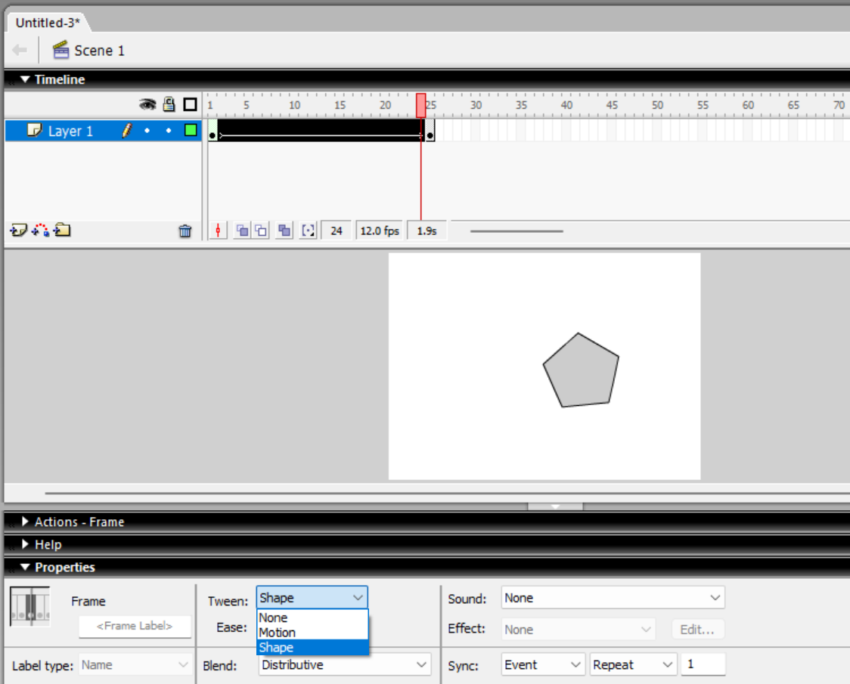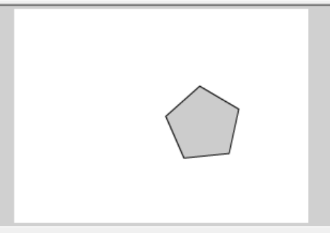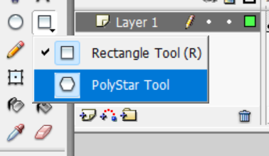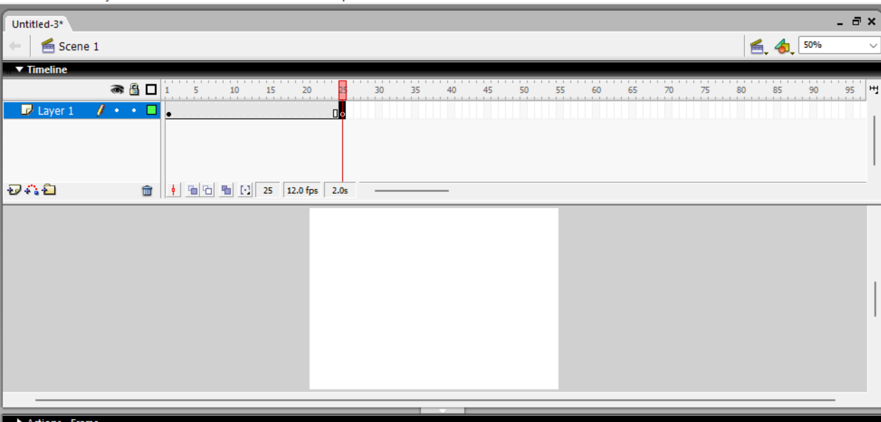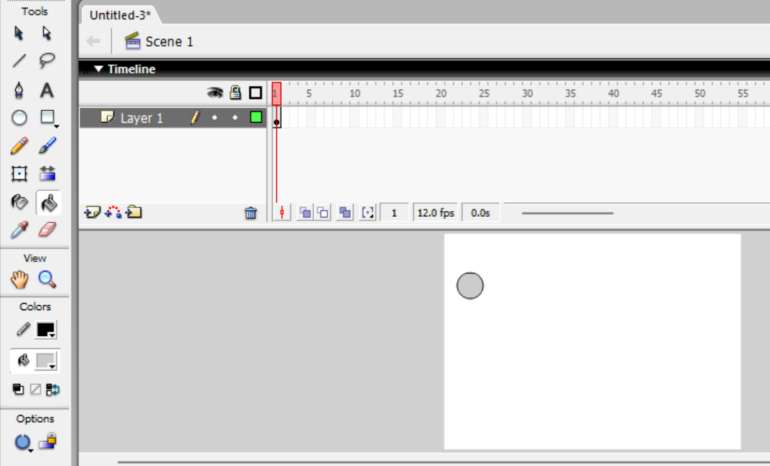

19. Write the step by step procedure with snapshot to perform motion tween in flash

interface.

* Create a new Flash document
* Use the Oval tool to draw a simple ellipse and fill it with you favorite color.(notice that Flash automatically adds a keyframe at the frame 1 when you create the ellipse)
* Convert the ellipse to a graphic symbol by seelcting Modfy->Convert to Symbol, or by pressing f8. Make sure that the Graphich radio button is selected, and name the symbol Oval and click Ok.
* Click on frame 10 and isnert a new keyframe
* Move the ellipse to a new location on the stage
* Click on frame 1 in the timeline. In the properties Inspector, select “MOTION” in the tween drop-down menu
* Play the animation.



 